Application Details
1. Introduction
This chapter outlines the practical implementation of a cryptocurrency price forecasting system developed to assist investors in making informed financial decisions. The system applies time series forecasting techniques to historical cryptocurrency data in order to predict future price movements with greater accuracy and reliability.
The aim of the research is to enhance prediction quality by exploring three different modeling approaches: ARIMA, Prophet, and LSTM. These models were selected due to their ability to handle temporal patterns and adapt to different types of price behavior. The cryptocurrencies analyzed in this study include Bitcoin (BTC), Ethereum (ETH), and Binance Coin (BNB), which are widely recognized within digital financial markets.
A dual implementation strategy was followed. In the comparison phase, each model was trained on the dataset excluding the last 30 days, which were used for testing. This allowed for a fair assessment of model performance using evaluation metrics such as Mean Absolute Error (MAE), Root Mean Squared Error (RMSE), Mean Absolute Percentage Error (MAPE), and the R² score. For deployment, all models were trained on the full dataset and integrated into a web application. While ARIMA and Prophet forecast 30 days automatically, the LSTM model requires user input of the previous 7 days and optionally includes sentiment data.

2. Technology Stack and Tools
The cryptocurrency forecasting system was developed using Python due to its strong ecosystem for data science, machine learning, and time series analysis. The project required tools for data preprocessing, model training, performance evaluation, and web-based deployment.
Programming Language:
- Python: Chosen for its readability, flexibility, and rich ecosystem of scientific and analytical libraries.
Libraries and Frameworks:
- pandas, NumPy: Used for data manipulation, handling time series structures, and numerical operations.
- matplotlib, seaborn: Employed for creating visualizations such as time series plots, distribution graphs, and error diagnostics.
- statsmodels: Utilized for implementing ARIMA models and performing stationarity checks.
- prophet: A trend-based forecasting tool used for capturing seasonality and growth trends with minimal configuration.
- TensorFlow, Keras: Applied for building and training LSTM neural networks due to their support for sequential deep learning.
- scikit-learn: Used for preprocessing (e.g., scaling) and evaluating model performance using metrics such as:
  - Mean Absolute Error (MAE)
  - Root Mean Squared Error (RMSE)
  - Mean Absolute Percentage Error (MAPE)
  - R-squared score (R²)
- vaderSentiment: To calculate sentiment score.
Deployment Framework:
- Streamlit: Selected to develop a lightweight, interactive web application that allows users to input cryptocurrency data, view model predictions, and interact with each model's output in real time.
- Docker: To containerize the app and make it ready for deployment
- Render: To deploy/host the Web App.
Development Environment:
- Jupyter Notebook: Used for initial prototyping, data exploration, and experimentation.
- Visual Studio Code (VSCode): Employed for writing modular Python scripts and managing the full project structure.
- Google Colab: Utilized for training models, especially LSTM, on datasets using GPU acceleration.
This combination of tools enabled efficient development, testing, and deployment of the end-to-end forecasting application.

3. Data Preprocessing and Integration
To effectively forecast cryptocurrency prices, both historical market data and crypto-related news headlines were collected and processed. Integrating these two sources aimed to enhance predictive accuracy by combining quantitative indicators with sentiment-driven signals.
Data Sources
- Market Data for Bitcoin (BTC), Ethereum (ETH), and Binance Coin (BNB) was sourced from Kaggle
(https://www.kaggle.com/datasets/abdullahdatascience/crypto-coins-dataset-2013-2025).
The dataset included daily Open, High, Low, Close prices, Volume, and Market Cap etc.

Figure 1:
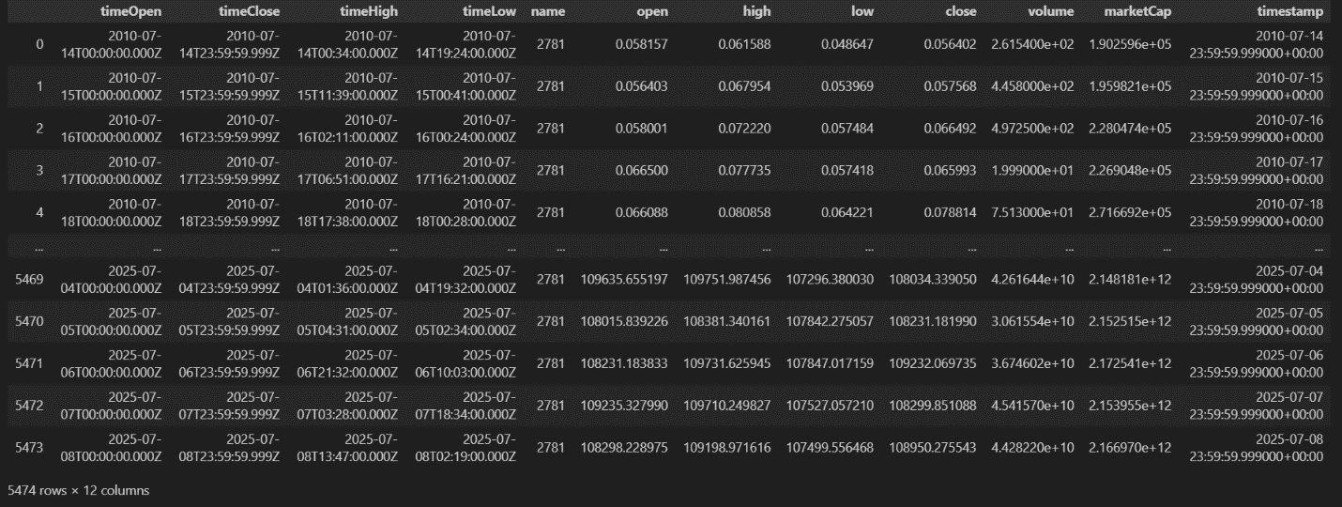
Source:
df_btc=pd.read_csv("BTC_merged_2010_to_2025.csv")
df_btc
- News Headlines were obtained from GitHub
(https://github.com/soheilrahsaz/cryptoNewsDataset), providing crypto-related headlines used to extract sentiment signals.
Figure 2:
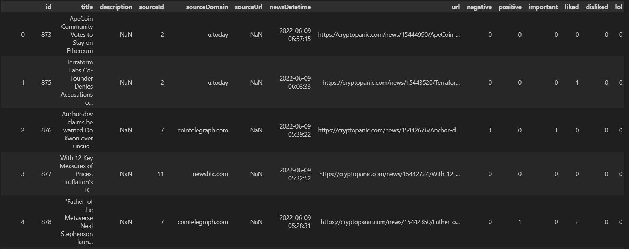
Source:
df_news=pd.read_csv("dataset/News/news_currencies_source_joinedResult.csv")
df_news

Preprocessing Steps
The preprocessing pipeline was structured as follows:
- File Collection
All CSV files were loaded into pandas DataFrames. For each coin, CSV file was loaded into a separate DataFrame to ensure a continuous and complete record.
Source:
df_btc=pd.read_csv("Dataset\BTC_merged_2010_to_2025.csv")
df_eth=pd.read_csv("Dataset\ETH_merged_2015_to_2025.csv")
df_bnb=pd.read_csv("Dataset\BNB_merged_2017_to_2025.csv")

- Datetime Conversion and Sorting
The timestamp columns were converted to datetime objects using pandas.to_datetime(). All datasets were sorted in chronological order to preserve the time series structure required for modeling.
Source:
# Convert 'timestamp' to datetime
df_btc['timestamp'] = pd.to_datetime(df_btc['timestamp'])
# Sort by timestamp
df_btc.sort_values('timestamp', inplace=True)
# Remove timezone
df_btc['timestamp'] = df_btc['timestamp'].dt.tz_localize(None)

- Data Cleaning
Column headers were stripped of extra whitespaces to avoid key mismatches. Duplicate rows and invalid records were identified and removed to ensure data quality and prevent distortion of model training. Useless columns were also removed for each coin dataset.
Figure 3 (For coin dataset):
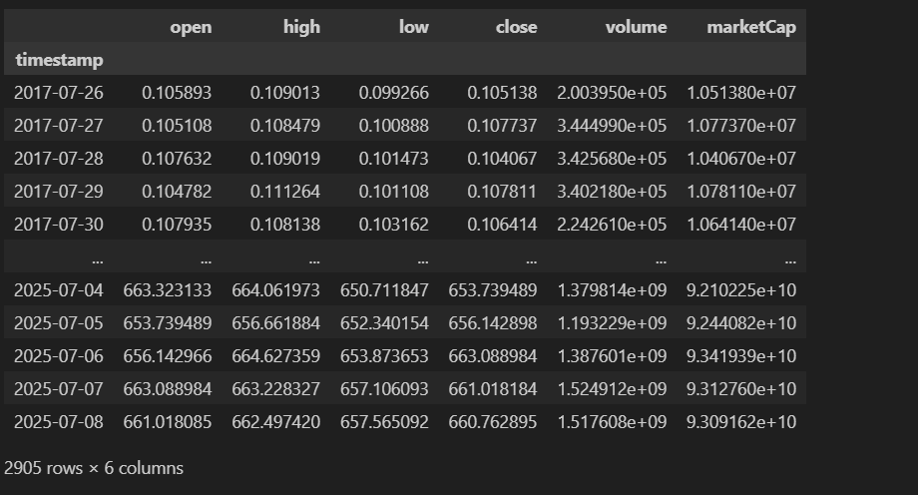
Source:
# Drop irrelevant columns
df_bnb.drop(columns=['timeOpen', 'timeClose', 'timeHigh', 'timeLow', 'name'], inplace=True)
# Convert 'timestamp' to datetime
df_bnb['timestamp'] = pd.to_datetime(df_bnb['timestamp'])
# Sort by timestamp
df_bnb.sort_values('timestamp', inplace=True)
# Remove timezone
df_bnb['timestamp'] = df_bnb['timestamp'].dt.tz_localize(None)
# Set timestamp as index and normalize
df_bnb.set_index('timestamp', inplace=True)
df_bnb.index = df_bnb.index.normalize()
# Final cleaned DataFrame
df_bnb_clean = df_bnb.copy()
# Save to CSV
df_bnb_clean.to_csv("BNB_cleaned.csv")
print("BNB data cleaned and saved as BNB_cleaned.csv")

Figure 4 (news dataset):
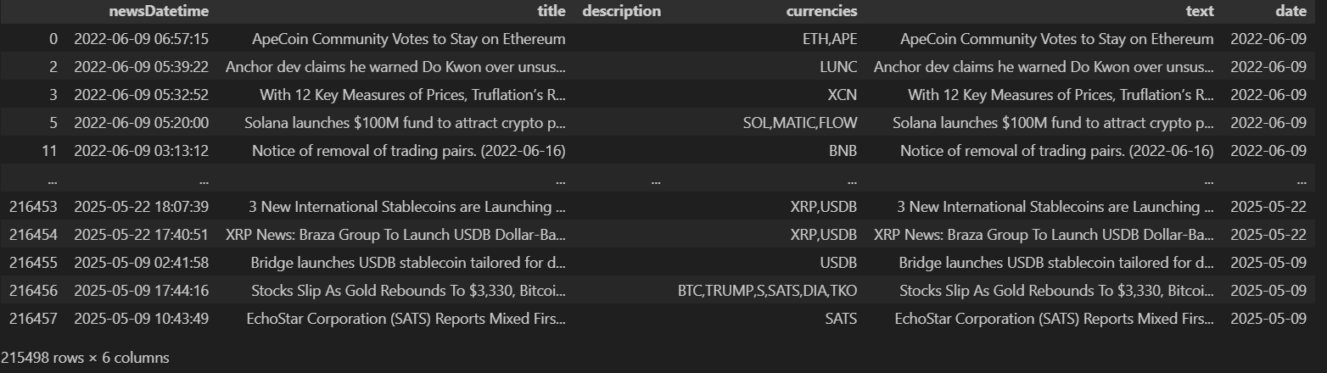
Source:
import pandas as pd
from vaderSentiment.vaderSentiment import SentimentIntensityAnalyzer
# Step 1: Load and clean news data
news_df = pd.read_csv("E:\Abdullah\Code\Crypto_price_prediction\Dataset\pnews_currencies_source_joinedResult.csv")
# Keep only needed columns
news_df = news_df[['newsDatetime', 'title', 'description', 'currencies']]
# Drop rows with no title or no coin information
news_df.dropna(subset=['title', 'currencies'], inplace=True)
# Fill missing descriptions
news_df['description'] = news_df['description'].fillna('')
# Combine title and description into a new column
news_df['text'] = news_df['title'] + " " + news_df['description']
# Convert datetime and extract date only
news_df['date'] = pd.to_datetime(news_df['newsDatetime']).dt.date

- Sentiment Scoring
The VADER sentiment analysis tool from the vaderSentiment.vaderSentiment library was used to calculate a sentiment score for each headline. The compound score, which ranges from -1 (very negative) to +1 (very positive), was selected. Daily average sentiment values were computed for each coin.
Figure 5:
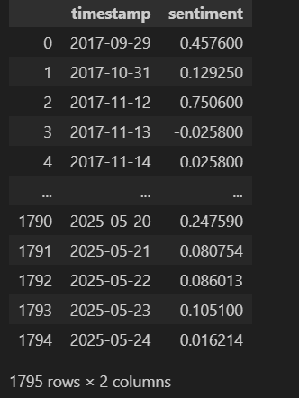
Source:
from vaderSentiment.vaderSentiment import SentimentIntensityAnalyzer
analyzer = SentimentIntensityAnalyzer()
news_df['sentiment'] = news_df['text'].apply(lambda x: analyzer.polarity_scores(x)['compound'])
df_news["currencies"].value_counts()

# Helper function to filter and aggregate
def get_daily_sentiment(df, coin_symbol):
df_coin = df[df['currencies'].str.contains(coin_symbol, na=False)].copy()
daily_sentiment = df_coin.groupby('date')['sentiment'].mean().reset_index()
daily_sentiment.columns = ['timestamp', 'sentiment']
return daily_sentiment

# Generate sentiment per coin
btc_sentiment = get_daily_sentiment(news_df, 'BTC')
eth_sentiment = get_daily_sentiment(news_df, 'ETH')
bnb_sentiment = get_daily_sentiment(news_df, 'BNB')

btc_sentiment.to_csv("BTC_sentiment.csv", index=False)
eth_sentiment.to_csv("ETH_sentiment.csv", index=False)
bnb_sentiment.to_csv("BNB_sentiment.csv", index=False)

print("Sentiment files saved")

- Merging Sentiment with Market Data
The sentiment data was merged with the corresponding market dataset by aligning on both timestamps and coin identifiers. This integration produced a unified dataset capturing both price movements and public sentiment.
Figure 6:
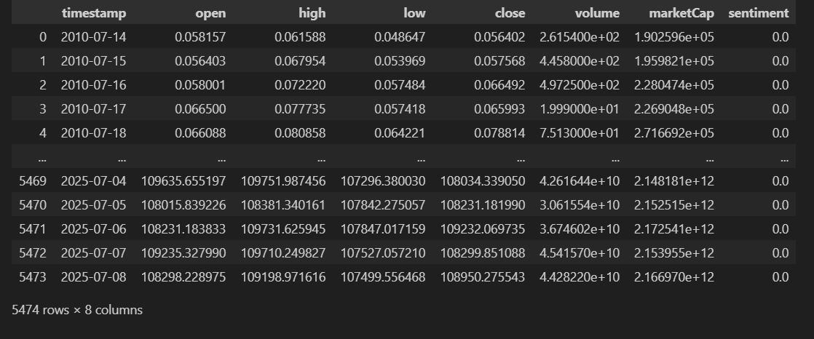
Source:
# Example: Merge BTC sentiment into BTC price data
btc_df = pd.read_csv("BTC_cleaned.csv", parse_dates=['timestamp'])
btc_sentiment = pd.read_csv("BTC_sentiment.csv", parse_dates=['timestamp'])
# Merge (keep all price data, add sentiment if available)
btc_merged = pd.merge(btc_df, btc_sentiment, on='timestamp', how='left')
# Fill missing sentiment with 0 (or neutral)
btc_merged['sentiment'] = btc_merged['sentiment'].fillna(0)
btc_merged.to_csv("BTC_final.csv", index=False)

- Handling Missing Sentiment
On days with no news headlines or unmatched timestamps, sentiment scores were filled with 0. This approach maintained continuity in the dataset while reflecting the absence of sentiment data.
Source:
# Fill missing sentiment with 0 (or neutral)
btc_merged['sentiment'] = btc_merged['sentiment'].fillna(0)

This preprocessing workflow ensured a clean, consistent, and sentiment-aware dataset ready for time series forecasting with ARIMA, Prophet, and LSTM models.

4. Model Implementation
To forecast cryptocurrency prices and analyze the impact of news sentiment, three distinct time series modeling approaches were implemented: ARIMA/ARIMAX, Prophet, and LSTM. Each model was applied for both offline comparison and real-time deployment in a web application built with Streamlit. The goal was to evaluate forecasting accuracy, input flexibility, and real-world usability.
ARIMA / ARIMAX
The ARIMA model was selected for its effectiveness in modeling linear trends and its interpretability. A configuration of (5,1,0) was chosen after analyzing autocorrelation and partial autocorrelation plots. This setup ensured appropriate differencing and lag selection to model the underlying patterns in the cryptocurrency time series.
For comparison, two versions of the model were trained:
- ARIMA, using only historical price data.
- ARIMAX, which integrated sentiment scores as an exogenous variable to assess their impact on predictions.
Both models were trained on data excluding the final 30 days, which were then used as a test set to evaluate forecasting performance. Metrics such as RMSE, MAE, and MAPE were used to compare the models with and without sentiment.
In the deployed application, the ARIMAX model was implemented using SARIMAX to allow the inclusion of external sentiment variables. The model was trained on the complete dataset and used to forecast the next 30 days automatically. It required no user input and offered a static but comprehensive outlook. This made it suitable for users interested in longer-term trends influenced by external market signals like news sentiment.
(Note: This section contains only the models used for Web app and deployment, Model comparison will be discussed in the next chapter.)
Figure 7:
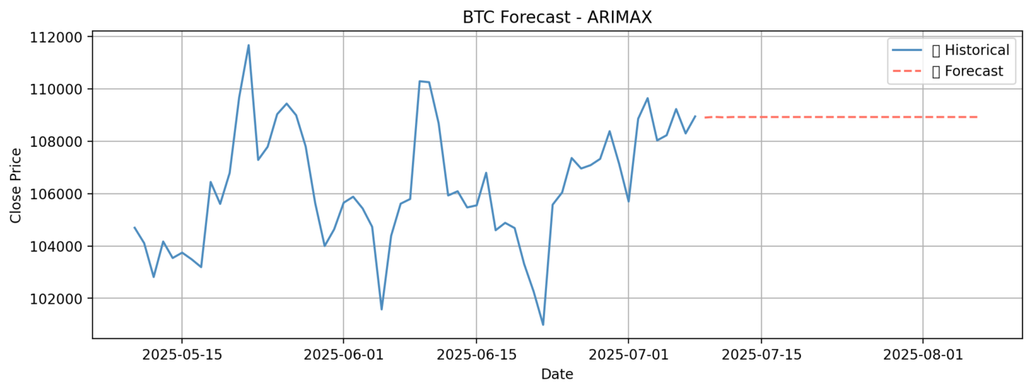
Source:
import pandas as pd
import numpy as np
import matplotlib.pyplot as plt
from statsmodels.tsa.arima.model import ARIMA
from statsmodels.tsa.statespace.sarimax import SARIMAX
from sklearn.preprocessing import MinMaxScaler
df = pd.read_csv("BTC_final.csv", parse_dates=['timestamp'])
df.set_index('timestamp', inplace=True)
# Fill missing sentiment
df['sentiment'] = df['sentiment'].fillna(0)
# Target and exogenous features
y = df['close']
exog = df[['sentiment']]
# Train ARIMAX on full data (no test split)
model = SARIMAX(y, exog=exog, order=(5, 1, 0))
model_fit = model.fit(disp=False)
# Forecast for next 30 days
# Prepare exog for the future (use average or 0 if no future sentiment is known)
future_dates = pd.date_range(start=df.index[-1] + pd.Timedelta(days=1), periods=30, freq='D')
future_sentiment = pd.DataFrame({'sentiment': [0] * 30}, index=future_dates)
# Predict
forecast = model_fit.forecast(steps=30, exog=future_sentiment)
# Plot forecast
plt.figure(figsize=(12, 4))
plt.plot(y.index[-60:], y[-60:], label='Historical (Last 60 Days)')
plt.plot(forecast.index, forecast, label='Forecast (Next 30 Days)', linestyle='--')
plt.title("🔮 ARIMAX Forecast - BTC Close Price (Next 30 Days)")
plt.xlabel("Date")
plt.ylabel("BTC Price (USD)")
plt.xticks(rotation=45)
plt.legend()
plt.grid()
plt.tight_layout()
plt.show()

Figure 8:
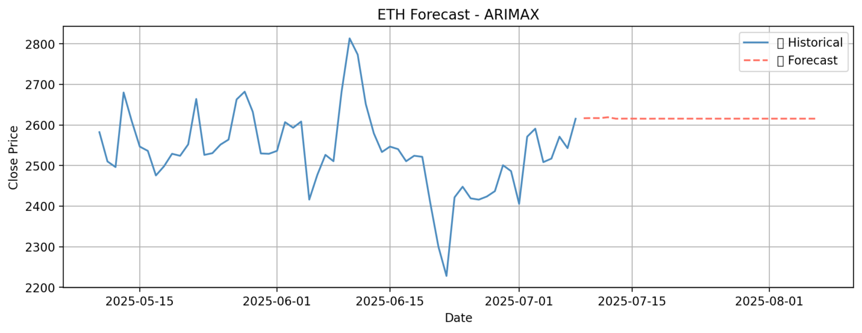
Source:
import pandas as pd
import numpy as np
import matplotlib.pyplot as plt
from statsmodels.tsa.arima.model import ARIMA
from statsmodels.tsa.statespace.sarimax import SARIMAX
from sklearn.preprocessing import MinMaxScaler
df = pd.read_csv("ETH_final.csv", parse_dates=['timestamp'])
df.set_index('timestamp', inplace=True)
# Fill missing sentiment
df['sentiment'] = df['sentiment'].fillna(0)
# Target and exogenous features
y = df['close']
exog = df[['sentiment']]
# Train ARIMAX on full data (no test split)
model = SARIMAX(y, exog=exog, order=(5, 1, 0))
model_fit = model.fit(disp=False)
# Forecast for next 30 days
# Prepare exog for the future (use average or 0 if no future sentiment is known)
future_dates = pd.date_range(start=df.index[-1] + pd.Timedelta(days=1), periods=30, freq='D')
future_sentiment = pd.DataFrame({'sentiment': [0] * 30}, index=future_dates)
# Predict
forecast = model_fit.forecast(steps=30, exog=future_sentiment)
# Plot forecast
plt.figure(figsize=(12, 4))
plt.plot(y.index[-60:], y[-60:], label='Historical (Last 60 Days)')
plt.plot(forecast.index, forecast, label='Forecast (Next 30 Days)', linestyle='--')
plt.title(" ARIMAX Forecast - ETH Close Price (Next 30 Days)")
plt.xlabel("Date")
plt.ylabel("ETH Price (USD)")
plt.xticks(rotation=45)
plt.legend()
plt.grid()
plt.tight_layout()
plt.show()

Figure 9:
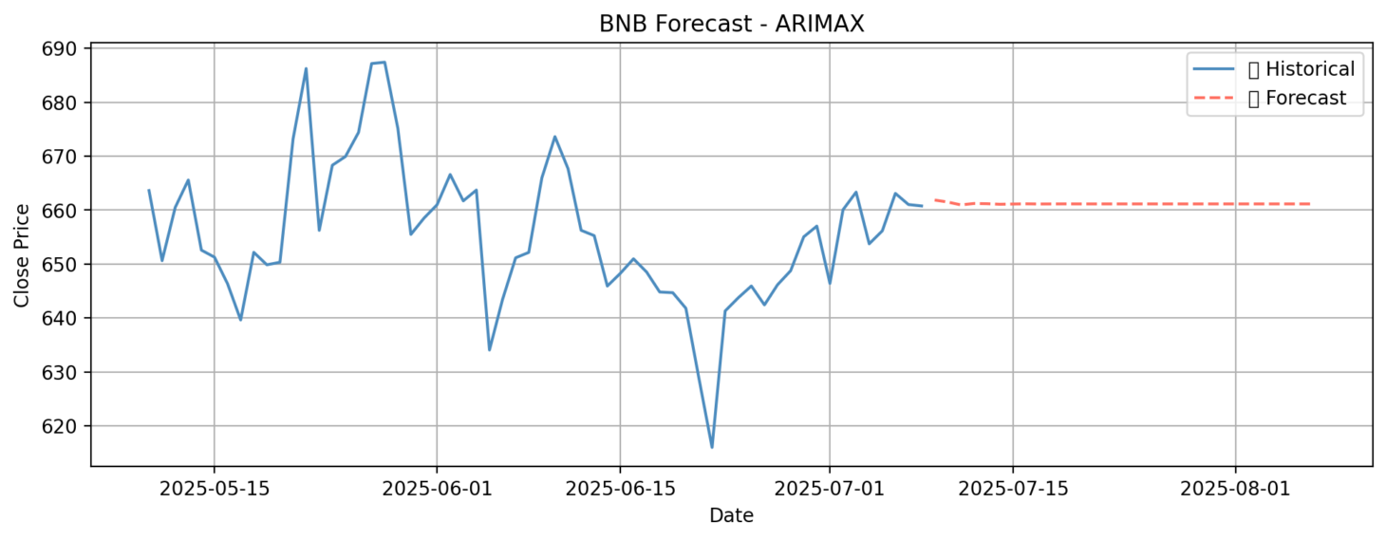
Source:
import pandas as pd
import numpy as np
import matplotlib.pyplot as plt
from statsmodels.tsa.arima.model import ARIMA
from statsmodels.tsa.statespace.sarimax import SARIMAX
from sklearn.preprocessing import MinMaxScaler
df = pd.read_csv("BNB_final.csv", parse_dates=['timestamp'])
df.set_index('timestamp', inplace=True)
# Fill missing sentiment
df['sentiment'] = df['sentiment'].fillna(0)

# Target and exogenous features
y = df['close']
exog = df[['sentiment']]
# Train ARIMAX on full data (no test split)
model = SARIMAX(y, exog=exog, order=(5, 1, 0))
model_fit = model.fit(disp=False)
# Forecast for next 30 days
# Prepare exog for the future (use average or 0 if no future sentiment is known)
future_dates = pd.date_range(start=df.index[-1] + pd.Timedelta(days=1), periods=30, freq='D')
future_sentiment = pd.DataFrame({'sentiment': [0] * 30}, index=future_dates)
# Predict
forecast = model_fit.forecast(steps=30, exog=future_sentiment)
# Plot forecast
plt.figure(figsize=(12, 4))
plt.plot(y.index[-60:], y[-60:], label='Historical (Last 60 Days)')
plt.plot(forecast.index, forecast, label='Forecast (Next 30 Days)', linestyle='--')
plt.title(" ARIMAX Forecast - BNB Close Price (Next 30 Days)")
plt.xlabel("Date")
plt.ylabel("BNB Price (USD)")
plt.xticks(rotation=45)
plt.legend()
plt.grid()
plt.tight_layout()
plt.show()

Prophet
The Prophet model, developed by Facebook, was chosen for its flexibility and ability to handle seasonality and trend changes in time series data. Its intuitive configuration made it accessible while still offering robust performance for financial forecasting.
Two variants of the model were developed:
- The first used only price data and daily seasonality to predict future trends.
- The second included sentiment scores added as a custom regressor using Prophet’s built-in add_regressor() functionality.
Both versions were trained on the dataset excluding the last 30 days and then tested on that reserved period for comparative analysis. Prophet’s ability to automatically detect changepoints and adapt to holiday-like effects made it a strong candidate for capturing shifts in market behavior.
For application deployment, only the sentiment-enhanced version was used. This model was trained on the full dataset to ensure the best performance and was capable of forecasting the next 30 days without any user interaction. Like ARIMAX, Prophet’s integration into the application was designed for ease of use, offering automatic and consistent outputs that updated with newly available data.
Prophet performed reliably across all three cryptocurrencies and proved to be easy to tune. Its strength in modeling smooth long-term trends, while accommodating sentiment as an influencing factor, made it well-suited for the web app’s passive forecasting features.
Figure 10:
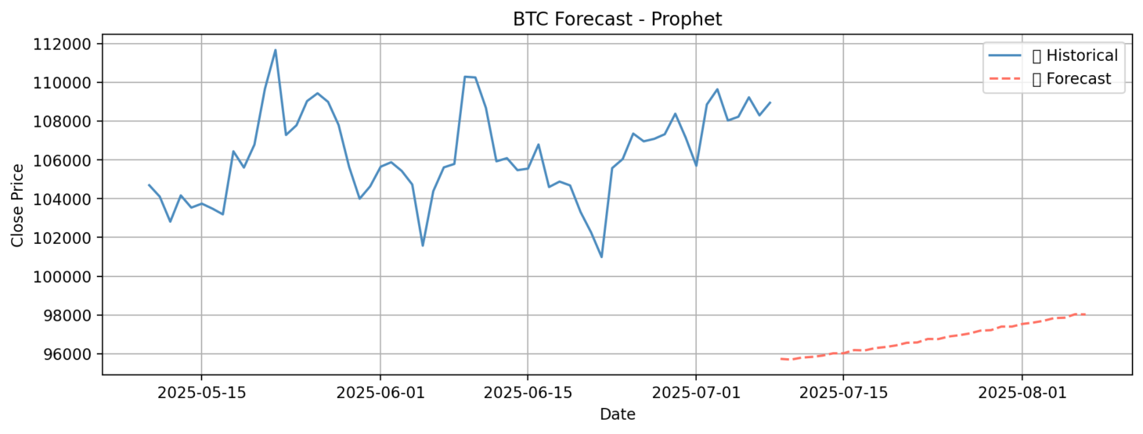
Source:
import pandas as pd
import numpy as np
import matplotlib.pyplot as plt
from prophet import Prophet
from sklearn.preprocessing import MinMaxScaler
df_btc = pd.read_csv("BTC_final.csv", parse_dates=['timestamp'])
# Rename columns for Prophet
df_prophet = df_btc[['timestamp', 'close', 'sentiment']].rename(columns={
'timestamp': 'ds',
'close': 'y'
})
# Fill missing sentiment (if any)
df_prophet['sentiment'] = df_prophet['sentiment'].fillna(0)
# Initialize and train Prophet model with sentiment as regressor
model = Prophet(daily_seasonality=True)
model.add_regressor('sentiment')
model.fit(df_prophet)
# Predict the NEXT 30 DAYS after the last date in dataset
future = model.make_future_dataframe(periods=30)
# Add default sentiment = 0 for future (can be updated dynamically)
future_sentiment = [0] * 30
future['sentiment'] = pd.concat([df_prophet['sentiment'], pd.Series(future_sentiment)], ignore_index=True)
# Predict
forecast = model.predict(future)
# Extract forecasted part (next 30 days)
forecast_next_30 = forecast.set_index('ds').tail(30)['yhat']
# Get last 60 days of actuals for consistent plotting
actual_last_60 = df_prophet.set_index('ds')['y'].iloc[-60:]
# Plot
plt.figure(figsize=(12, 4))
plt.plot(actual_last_60.index, actual_last_60, label='Historical (Last 60 Days)')
plt.plot(forecast_next_30.index, forecast_next_30, label='Forecast (Next 30 Days)', linestyle='--')
plt.title(" BTC Price Forecast - Prophet (Recent History + 30-Day Forecast)")
plt.xlabel("Date")
plt.ylabel("BTC Close Price (USD)")
plt.xticks(rotation=45)
plt.grid(True)
plt.legend()
plt.tight_layout()
plt.show()

Figure 11:
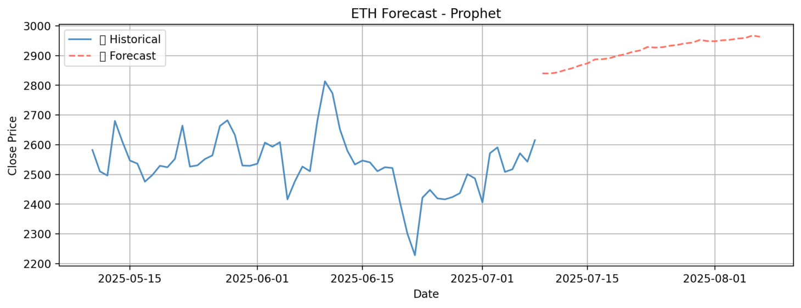
Source:
import pandas as pd
import numpy as np
import matplotlib.pyplot as plt
from prophet import Prophet
from sklearn.preprocessing import MinMaxScaler
df_eth = pd.read_csv("ETH_final.csv", parse_dates=['timestamp'])
# Rename columns for Prophet
df_prophet = df_eth[['timestamp', 'close', 'sentiment']].rename(columns={
'timestamp': 'ds',
'close': 'y'
})
# Fill missing sentiment (if any)
df_prophet['sentiment'] = df_prophet['sentiment'].fillna(0)
# Initialize and train Prophet model with sentiment as regressor
model = Prophet(daily_seasonality=True)
model.add_regressor('sentiment')
model.fit(df_prophet)
# Predict the NEXT 30 DAYS after the last date in dataset
future = model.make_future_dataframe(periods=30)
# Add default sentiment = 0 for future (can be updated dynamically)
future_sentiment = [0] * 30
future['sentiment'] = pd.concat([df_prophet['sentiment'], pd.Series(future_sentiment)], ignore_index=True)
# Predict
forecast = model.predict(future)
# Extract forecasted part (next 30 days)
forecast_next_30 = forecast.set_index('ds').tail(30)['yhat']
# Get last 60 days of actuals for consistent plotting
actual_last_60 = df_prophet.set_index('ds')['y'].iloc[-60:]
# Plot
plt.figure(figsize=(12, 4))
plt.plot(actual_last_60.index, actual_last_60, label='Historical (Last 60 Days)')
plt.plot(forecast_next_30.index, forecast_next_30, label='Forecast (Next 30 Days)', linestyle='--')
plt.title("🔮 ETH Price Forecast - Prophet (Recent History + 30-Day Forecast)")
plt.xlabel("Date")
plt.ylabel("ETH Close Price (USD)")
plt.xticks(rotation=45)
plt.grid(True)
plt.legend()
plt.tight_layout()
plt.show()

Figure 12:
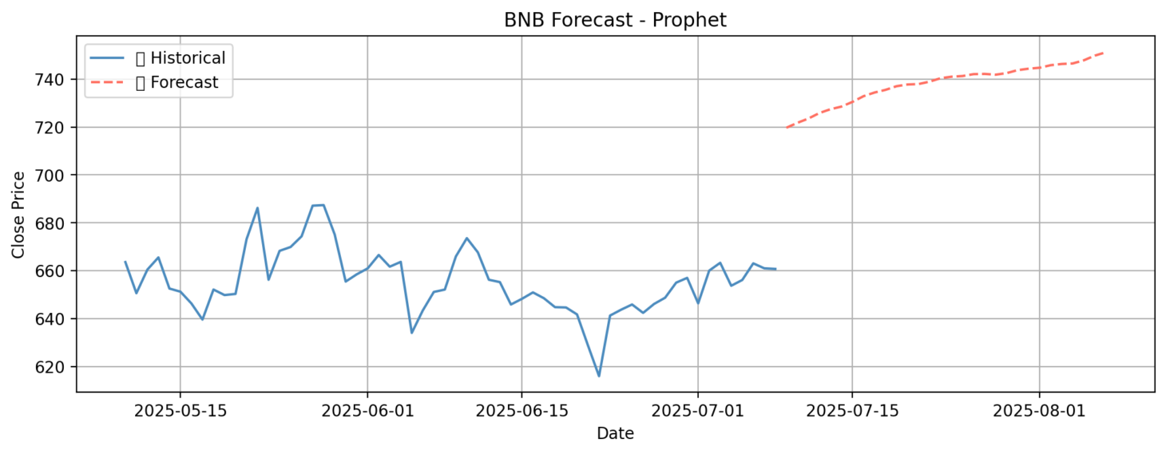
Source:
import pandas as pd
import numpy as np
import matplotlib.pyplot as plt
from prophet import Prophet
from sklearn.preprocessing import MinMaxScaler
df_bnb = pd.read_csv("BNB_final.csv", parse_dates=['timestamp'])
# Rename columns for Prophet
df_prophet = df_bnb[['timestamp', 'close', 'sentiment']].rename(columns={
'timestamp': 'ds',
'close': 'y'
})
# Fill missing sentiment (if any)
df_prophet['sentiment'] = df_prophet['sentiment'].fillna(0)
# Initialize and train Prophet model with sentiment as regressor
model = Prophet(daily_seasonality=True)
model.add_regressor('sentiment')
model.fit(df_prophet)
# Predict the NEXT 30 DAYS after the last date in dataset
future = model.make_future_dataframe(periods=30)
# Add default sentiment = 0 for future (can be updated dynamically)
future_sentiment = [0] * 30
future['sentiment'] = pd.concat([df_prophet['sentiment'], pd.Series(future_sentiment)], ignore_index=True)
# Predict
forecast = model.predict(future)
# Extract forecasted part (next 30 days)
forecast_next_30 = forecast.set_index('ds').tail(30)['yhat']
# Get last 60 days of actuals for consistent plotting
actual_last_60 = df_prophet.set_index('ds')['y'].iloc[-60:]
# Plot
plt.figure(figsize=(12, 4))
plt.plot(actual_last_60.index, actual_last_60, label='Historical (Last 60 Days)')
plt.plot(forecast_next_30.index, forecast_next_30, label='Forecast (Next 30 Days)', linestyle='--')
plt.title(" BNB Price Forecast - Prophet (Recent History + 30-Day Forecast)")
plt.xlabel("Date")
plt.ylabel("BNB Close Price (USD)")
plt.xticks(rotation=45)
plt.grid(True)
plt.legend()
plt.tight_layout()
plt.show()

LSTM
The LSTM (Long Short-Term Memory) model was selected to capture nonlinear dependencies and short-term temporal patterns that traditional statistical models often overlook. Unlike ARIMA and Prophet, which operate on entire time series, LSTM uses sliding input windows to make sequential predictions, making it better equipped for reacting to recent market movements.
For model evaluation, the LSTM was trained on historical data with the last 30 days held out for testing. Input sequences were constructed using a 30-day window of scaled close prices and corresponding sentiment values. The model then predicted the next time step, and this process was repeated for multi-step forecasting. Performance was assessed using RMSE, MAE, MAPE, and R², and results were visualized against actual market prices to highlight predictive accuracy.
For deployment in the Streamlit application, a more interactive setup was adopted. Users are required to input the previous 7 days of close prices, with the option to also include sentiment values for each day. The model, trained using a 7-in → 7-out multi-step sequence structure, forecasts prices for the next 7 days.
Training was performed on the complete dataset to maximize learning, using 50 LSTM units, the Adam optimizer, and mean squared error as the loss function. Training epochs ranged between 20 and 50 depending on the dataset size and convergence speed.
Unlike ARIMA and Prophet, which are automated and static in their deployment, the LSTM model in the app responds dynamically to user input. This allows users to generate custom forecasts based on their own data or observations, enabling a more personalized and flexible prediction experience.
Overall, each model was adapted not just to fit the data but also to suit different types of users and forecasting needs, from fully automated long-term predictions to user-driven short-term forecasting.
(Note: For LSTM Models, since user can give any input with any date that’s why we didn’t plot the past trend of data like we did in Arima and prophet)
Figure 13:
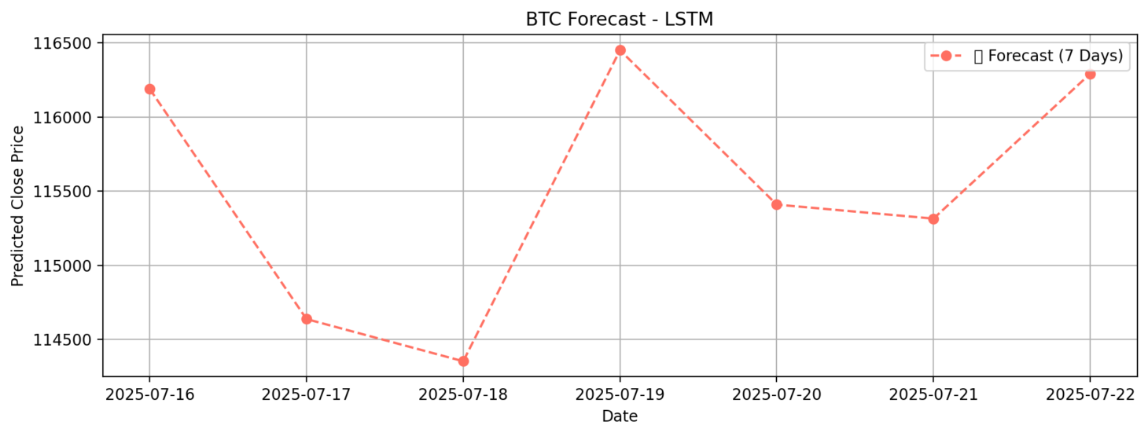
Source:

import pandas as pd
import numpy as np
import matplotlib.pyplot as plt
import tensorflow as tf
from tensorflow.keras.models import Sequential
from tensorflow.keras.layers import LSTM, Dense
from sklearn.preprocessing import MinMaxScaler
# Load dataset
df = pd.read_csv("BTC_final.csv", parse_dates=['timestamp'])
df.set_index('timestamp', inplace=True)
# Keep 'close' and 'sentiment'
data = df[['close', 'sentiment']].copy()
data['sentiment'] = data['sentiment'].fillna(0)
# Scale close price
price_scaler = MinMaxScaler()
data['scaled_close'] = price_scaler.fit_transform(data[['close']])
# Combine scaled_close + sentiment
scaled_data = data[['scaled_close', 'sentiment']].values
# Create 7-in, 7-out sequences
def create_sequences(data, input_days=7, forecast_days=7):
X, y = [], []
for i in range(input_days, len(data) - forecast_days + 1):
X.append(data[i - input_days:i]) # (7, 2)
y.append(data[i:i + forecast_days, 0]) # (7,)
return np.array(X), np.array(y)

X, y = create_sequences(scaled_data, input_days=7, forecast_days=7)
# Train on complete data
model = Sequential([
LSTM(64, input_shape=(7, 2), return_sequences=False),
Dense(7) # Predict next 7 days
])
model.compile(optimizer='adam', loss='mean_squared_error')
model.summary()
# Train model
history = model.fit(
X, y,
epochs=30,
batch_size=16,
verbose=1
)
# 🧾 Predict future 7 days from latest known data
last_sequence = scaled_data[-7:] # Shape: (7, 2)
last_sequence = np.expand_dims(last_sequence, axis=0) # Shape: (1, 7, 2)
future_pred_scaled = model.predict(last_sequence)[0] # Shape: (7,)
future_pred = price_scaler.inverse_transform(future_pred_scaled.reshape(-1, 1)).flatten()
# Plot last 30 actual + 7 predicted
last_30_actual = data['close'].values[-30:]
recent_dates = df.index[-30:]
future_dates = pd.date_range(start=df.index[-1] + pd.Timedelta(days=1), periods=7)
plt.figure(figsize=(12, 5))
plt.plot(recent_dates, last_30_actual, label='Actual (Last 30 Days)')
plt.plot(future_dates, future_pred, label='Forecast (Next 7 Days)', linestyle='--', marker='o')
plt.title(" LSTM BTC Forecast (7-in → 7-out)")
plt.xlabel("Date")
plt.ylabel("BTC Price (USD)")
plt.xticks(rotation=45)
plt.grid(True)
plt.legend()
plt.tight_layout()
plt.show()

Figure 14:
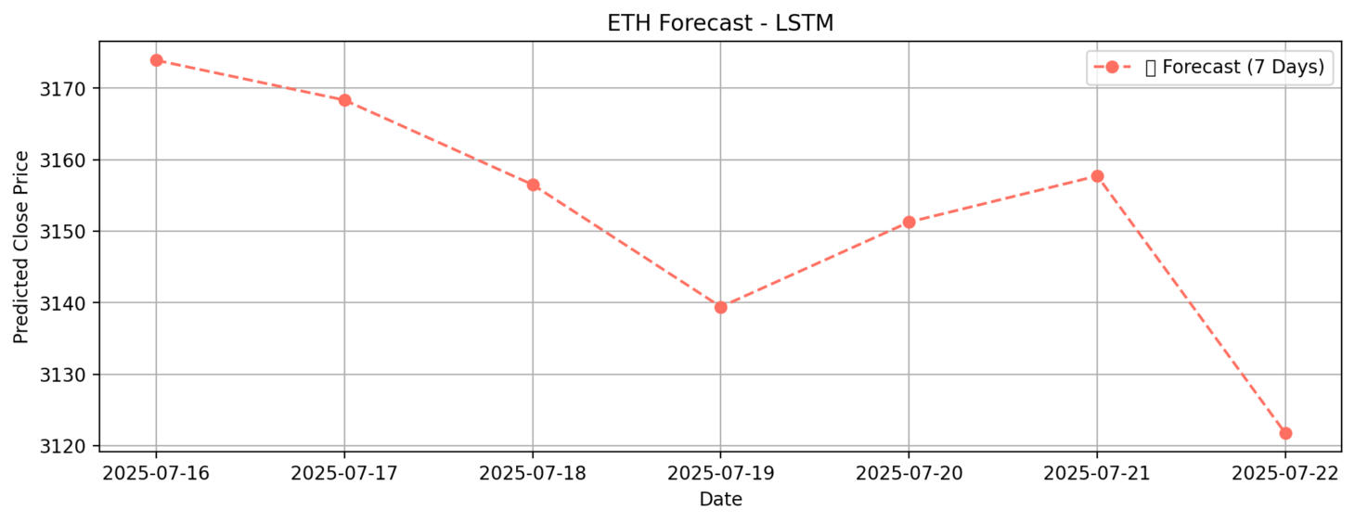
Source:

import pandas as pd
import numpy as np
import matplotlib.pyplot as plt
import tensorflow as tf
from tensorflow.keras.models import Sequential
from tensorflow.keras.layers import LSTM, Dense
from sklearn.preprocessing import MinMaxScaler
# Load dataset
df = pd.read_csv("ETH_final.csv", parse_dates=['timestamp'])
df.set_index('timestamp', inplace=True)
# Keep 'close' and 'sentiment'
data = df[['close', 'sentiment']].copy()
data['sentiment'] = data['sentiment'].fillna(0)
# Scale close price
price_scaler = MinMaxScaler()
data['scaled_close'] = price_scaler.fit_transform(data[['close']])
# Combine scaled_close + sentiment
scaled_data = data[['scaled_close', 'sentiment']].values
# Create 7-in, 7-out sequences
def create_sequences(data, input_days=7, forecast_days=7):
X, y = [], []
for i in range(input_days, len(data) - forecast_days + 1):
X.append(data[i - input_days:i]) # (7, 2)
y.append(data[i:i + forecast_days, 0]) # (7,)
return np.array(X), np.array(y)
X, y = create_sequences(scaled_data, input_days=7, forecast_days=7)
# Train on complete data
model = Sequential([
LSTM(64, input_shape=(7, 2), return_sequences=False),
Dense(7) # Predict next 7 days
])
model.compile(optimizer='adam', loss='mean_squared_error')
model.summary()
# Train model
history = model.fit(
X, y,
epochs=30,
batch_size=8,
verbose=1
)
# 🧾 Predict future 7 days from latest known data
last_sequence = scaled_data[-7:] # Shape: (7, 2)
last_sequence = np.expand_dims(last_sequence, axis=0) # Shape: (1, 7, 2)
future_pred_scaled = model.predict(last_sequence)[0] # Shape: (7,)
future_pred = price_scaler.inverse_transform(future_pred_scaled.reshape(-1, 1)).flatten()
# Plot last 30 actual + 7 predicted
last_30_actual = data['close'].values[-30:]
recent_dates = df.index[-30:]
future_dates = pd.date_range(start=df.index[-1] + pd.Timedelta(days=1), periods=7)
plt.figure(figsize=(12, 5))
plt.plot(recent_dates, last_30_actual, label='Actual (Last 30 Days)')
plt.plot(future_dates, future_pred, label='Forecast (Next 7 Days)', linestyle='--', marker='o')
plt.title("LSTM ETH Forecast (7-in → 7-out)")
plt.xlabel("Date")
plt.ylabel("ETH Price (USD)")
plt.xticks(rotation=45)
plt.grid(True)
plt.legend()
plt.tight_layout()
plt.show()

Figure 15:
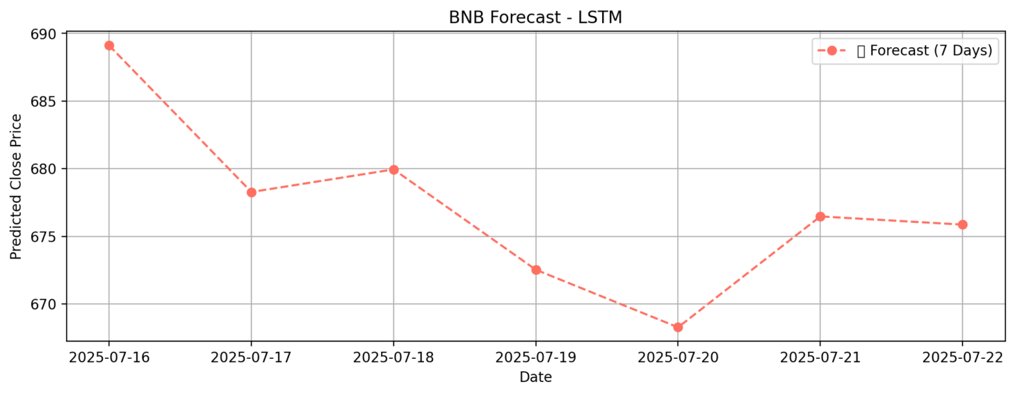
Source:

import pandas as pd
import numpy as np
import matplotlib.pyplot as plt
import tensorflow as tf
from tensorflow.keras.models import Sequential
from tensorflow.keras.layers import LSTM, Dense
from sklearn.preprocessing import MinMaxScaler
# Load dataset
df = pd.read_csv("BNB_final.csv", parse_dates=['timestamp'])
df.set_index('timestamp', inplace=True)
# Keep 'close' and 'sentiment'
data = df[['close', 'sentiment']].copy()
data['sentiment'] = data['sentiment'].fillna(0)
# Scale close price
price_scaler = MinMaxScaler()
data['scaled_close'] = price_scaler.fit_transform(data[['close']])
# Combine scaled_close + sentiment
scaled_data = data[['scaled_close', 'sentiment']].values
# Create 7-in, 7-out sequences
def create_sequences(data, input_days=7, forecast_days=7):
X, y = [], []
for i in range(input_days, len(data) - forecast_days + 1):
X.append(data[i - input_days:i]) # (7, 2)
y.append(data[i:i + forecast_days, 0]) # (7,)
return np.array(X), np.array(y)
X, y = create_sequences(scaled_data, input_days=7, forecast_days=7)
# Train on complete data
model = Sequential([
LSTM(64, input_shape=(7, 2), return_sequences=False),
Dense(7) # Predict next 7 days
])
model.compile(optimizer='adam', loss='mean_squared_error')
model.summary()
# Train model
history = model.fit(
X, y,
epochs=60,
batch_size=32,
verbose=1
)
# Predict future 7 days from latest known data
last_sequence = scaled_data[-7:] # Shape: (7, 2)
last_sequence = np.expand_dims(last_sequence, axis=0) # Shape: (1, 7, 2)
future_pred_scaled = model.predict(last_sequence)[0] # Shape: (7,)
future_pred = price_scaler.inverse_transform(future_pred_scaled.reshape(-1, 1)).flatten()
# Plot last 30 actual + 7 predicted
last_30_actual = data['close'].values[-30:]
recent_dates = df.index[-30:]
future_dates = pd.date_range(start=df.index[-1] + pd.Timedelta(days=1), periods=7)
plt.figure(figsize=(12, 5))
plt.plot(recent_dates, last_30_actual, label='Actual (Last 30 Days)')
plt.plot(future_dates, future_pred, label='Forecast (Next 7 Days)', linestyle='--', marker='o')
plt.title(" LSTM BNB Forecast (7-in → 7-out)")
plt.xlabel("Date")
plt.ylabel("BNB Price (USD)")
plt.xticks(rotation=45)
plt.grid(True)
plt.legend()
plt.tight_layout()
plt.show()
5. Application Interface
To make the forecasting models accessible and interactive, a web application was developed using Streamlit. The interface allows users to explore real-time cryptocurrency price forecasting with customizable options and intuitive controls.
The app enables users to select the cryptocurrency (BTC, ETH, or BNB), the desired forecasting model (ARIMA, Prophet, or LSTM), and the forecast duration. ARIMA and Prophet models are configured to predict the next 30 days, while LSTM forecasts 7 days ahead. If using ARIMA or Prophet with sentiment integration, a sentiment input slider ranging from -1 to 1 is provided. This simulates the impact of news sentiment on the model’s predictions.
For the LSTM model, users are prompted to enter the most recent 7 days of closing prices, along with optional sentiment values. The model then predicts the next week of prices based on this input.
The output includes clear visualizations:
- ARIMA and Prophet: a full 60-day plot (past 30 days + future 30 days)
- LSTM: a 7-day view next 7-day predictions
- All these plots are displayed in last heading.
All forecast results can be downloaded as a CSV file, enabling further analysis or record-keeping.
To maximize performance, each model is retrained on the full dataset before deployment in the application. This ensures the predictions are based on the most comprehensive data available. The interface provides an accessible platform for both expert users and casual investors to experiment with predictive analytics in the crypto domain.
We deployed the web application on Render using Docker containerization, which streamlined the deployment process. Docker enabled us to package the entire app, including all its dependencies and environment settings, into a single container. This ensured consistent behavior across different systems. Render’s native support for Docker made it easy to build, host, and scale the Streamlit application without complex setup, allowing for reliable and efficient deployment.

Figure 16 (User Interface of the Web App):
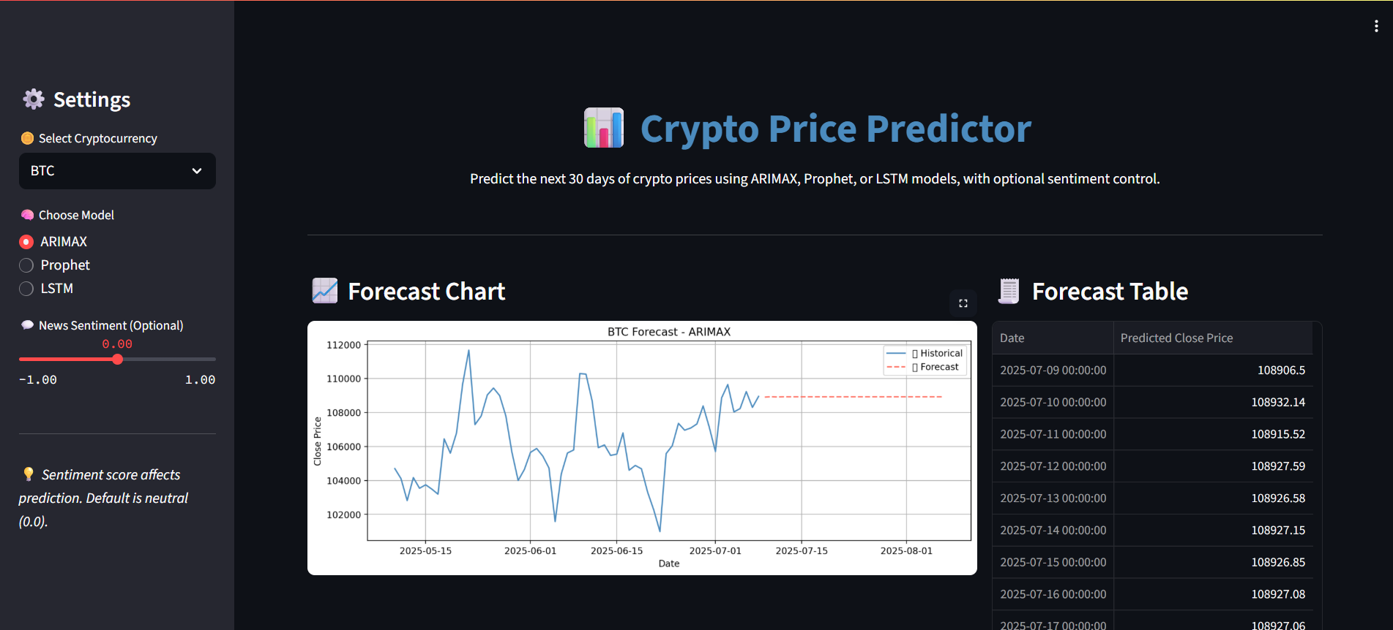
Source (Deployed on Render):
https://crypto-price-prediction-3z9g.onrender.com/

6. Summary
This project integrated ARIMA, Prophet, and LSTM models to forecast cryptocurrency prices for BTC, ETH, and BNB, adapting each model for both performance evaluation and real-time deployment. ARIMA and Prophet were configured to forecast 30 days ahead without requiring user input, with optional sentiment integration to enhance prediction accuracy. LSTM, on the other hand, required a 7-day input window (close prices and optional sentiment) to predict the next 7 days, making it more dynamic but also more interactive.
Each model was trained on historical data and validated against the most recent 30 days for fair comparison. For deployment, all models were retrained on the complete dataset to maximize learning. The application interface, developed using Streamlit, allowed seamless model selection, input control, and visualization, making advanced forecasting tools accessible to both technical and non-technical users.
The system was designed with modularity in mind, new data can be integrated easily, and models can be retrained without altering the app’s structure. This flexibility supports future improvements and scalability.
The following chapter presents evaluation metrics and beta testing results, providing a deeper analysis of model performance and usability under real-world conditions.

